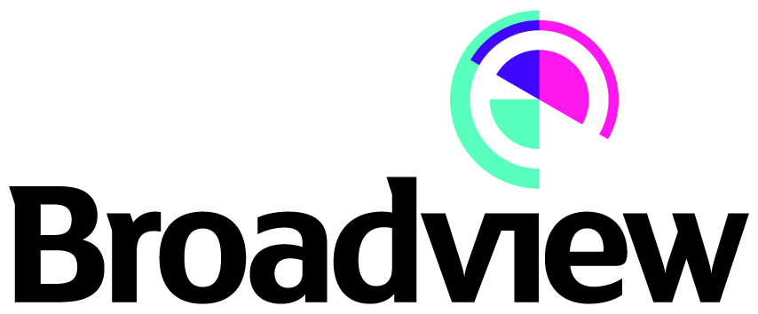

Press Release

Date of issue: 21 December 2018

Title: Broadview Energy Acquires Brockholes Community Energy Limited

A subsidiary of Broadview Energy’s Eolian Three investment vehicle has successfully completed the acquisition of a small wind farm project in Scotland from Mongoose Projects Limited.
The Brockholes wind farm project comprises of three Enercon E48 wind turbines and has a total installed capacity of 2.4 MW. The site located in Duns in the Scottish borders has been operational since 2012. Broadview Energy will be managing the operational aspects of the site on behalf of Eolian Three.
Jeffrey Corrigan, Managing Director, Broadview Energy, said “This is a high quality asset and we are pleased that our funding and project structuring allowed us to offer a valuation that proved attractive to the project’s vendor.”
Brockholes is Eoilan Three’s fifth acquisition since its inception in October 2017.
Notes to editors:
About Eolian Three
Eolian Three was established by Broadview Energy in October 2017 to invest in attractive small-scale renewable energy opportunities. In addition to Broadview, it currently has four shareholders all of whom have experience in the industry. Following the Brockholes acquisition, the Eolian Three portfolio consists of five Feed in Tariff wind farm projects totalling an installed capacity of 5.4MW.

Broadview Energy was established in 2006 and has successfully developed, financed, constructed and managed several renewable energy projects throughout the United Kingdom. It provides management services to Eolian Three as well as other investment funds.

More information on Brockholes wind farm project and Eolian funds can be obtained via Broadview Energy’s website http://broadviewenergy.com/.

For media enquiries, please contact:
Marcus Price Hafslund at Broadview Energy Limited (marcus@broadviewenergy.com / 020 7268 9911).

