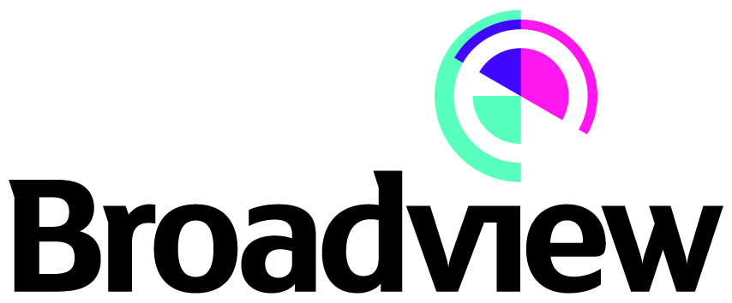

Press Release

Date of issue: 24th November 2017

Title: Establishment of Eolian Three and Acquisition of Peattie Wind Farm

Broadview Energy is pleased to announce the establishment of a new fund, Eolian Three Limited and its first acquisition.
Following on from the recent successful exits at its Eolian One and Two funds, Broadview Energy has established this new fund which will seek to acquire small Feed in Tariff and ROC projects. In order to assist in the funding of these acquisitions, Eolian Three has arranged a £20 million acquisition facility with Close Leasing Limited.
On 23rd November 2017, Eolian Three Limited acquired its first project, the 500 kW Peattie wind turbine, located in Inverbervie, Aberdeenshire. The site, owned by Windline (Peattie) Limited, went into operation in November 2015. Broadview Energy will be operating and managing the site on behalf of Eolian Three Limited.
Notes to editors:
Eolian One and Eolian Two were funds established by Broadview Energy and a group of leading industry professionals to provide a platform for individuals to invest in attractive renewable energy opportunities. The funds were dissolved following the sale of Westnewton and Watford Lodge wind farms in October 2017.

Broadview Energy was established in 2006 and has successfully developed, financed, constructed and managed several renewable energy projects throughout the United Kingdom. It provides management services to Eolian Three as well as other investment funds.
More information on the Peattie wind farm and Eolian funds can be obtained via Broadview Energy’s website http://broadviewenergy.com/.

For media enquiries, please contact:
Marcus Price Hafslund at Broadview Energy Limited (marcus@broadviewenergy.com / 020 7268 9911).

